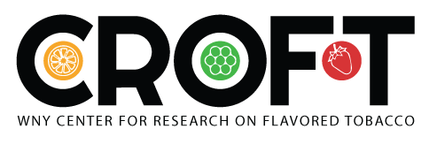

2019 TCORS Rapid Response Projects

Specific Aims Page Template

Please complete and return to CRoFT (croft@roswellpark.org) by Monday April 8, 2019, 5PM.

- RRP Research Question that your project will address.

Rapid Response Research Questions | Check the Question that your project will address
TOXICITY
Question A
What are the toxicological implications of specific ENDS constituents (e.g., nicotine concentration, nicotine salt vs. free-base nicotine, most popular flavors, PG/VG ratios, voltage delivery, types of delivery systems [e.g., JUUL-type products vs. other ENDS systems]) on ENDS users?
ADDICTION
Question D
What is the impact of ENDS and heat-not-burn product characteristics (including, but not limited to, different nicotine types [salt vs. free-base] and popular flavor categories) on abuse liability?
BEHAVIOR
Question I
What is the relationship between specific flavor categories (other than tobacco) on initiation, progression, and patterns of use among youth, young adult, and adult ENDS and/or cigar users?
Project Information
Please provide information for each item below. Your response to Items 6, 7, and 8 (together) should be limited to one page in total. For example, your response to individual item 6 should be approximately a paragraph or two, not a page.
- Project Title

- Collaboration with TCORS other than CRoFT? If so, which ones:

- Project PI and center:

- Co-investigators and centers:

- Brief background of the project

- Specific aims, objectives, hypotheses

- Significance and relevance of the proposed research to FDA’s regulatory authorities and the research question being addressed

